1. **Agenda**:
   1. Various states of an entity during its life cycle with an example.
2. 
3. **Transient State**:  
   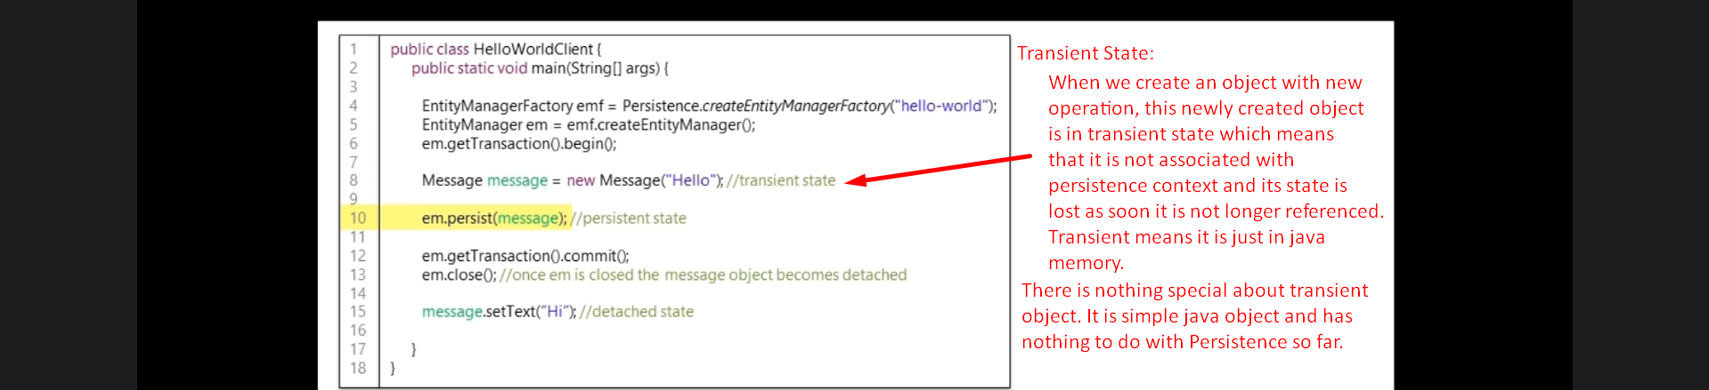 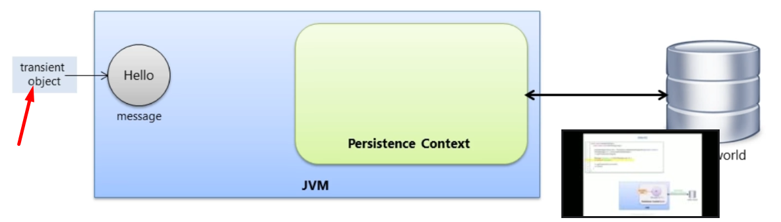
4. **Persistence State**:
   1. A persistence object is an object which has a Database Identity associated to it when we call entityManager.save(entityObject);
   2. The object has primary key value set as its DB identifier.

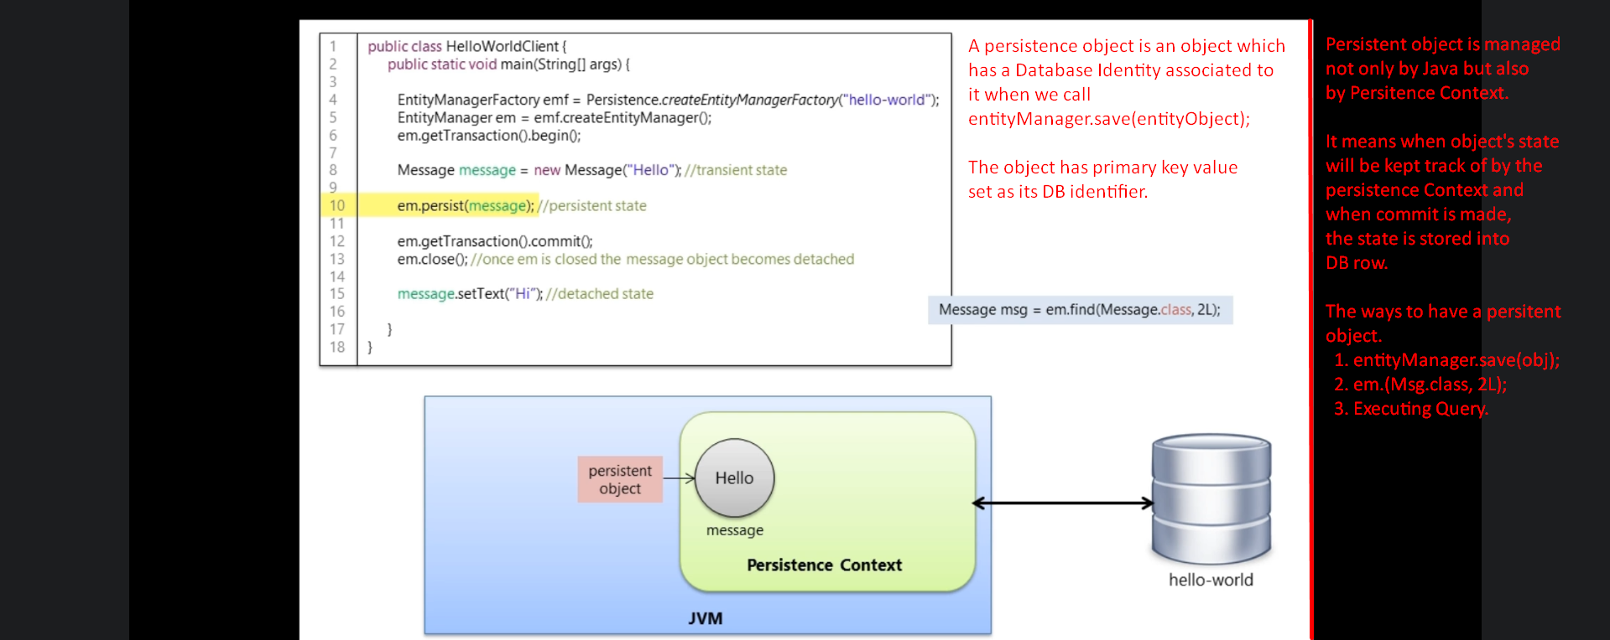

1. What is Persistence Context?
   1. It is first level cache.
   2. It has its own non-shared database connection.
   3. It does automatic dirty checking which means when transaction is committed, as it keeps track of data changes of a persistent object, it will save them into DB.  
      We will go into details in “Object Manipulation”.

